MINUTES – JANUARY 6, 2020

The Caswell County Board of Commissioners met in regular session at the Caswell County Historic Courthouse in Yanceyville, North Carolina at 9:00 a.m. on Monday, January 6, 2020. Members present: Rick McVey, Chairman, David Owen, Vice Chairman, Sterling Carter, Nathaniel Hall, Jeremiah Jefferies and Steve Oestreicher. Absent: William E. Carter. Also present: Bryan Miller, County Manager, Brian Ferrell, County Attorney, and Lanie Davis representing The Caswell Messenger. Paula P. Seamster, Clerk to the Board, recorded the minutes.

MOMENT OF SILENT PRAYER

Chairman McVey opened the meeting with a moment of Silent Prayer.

PLEDGE OF ALLEGIANCE

The Board of Commissioners and all the guests in the audience recited the Pledge of Allegiance.

APPROVAL OF AGENDA

Commissioner Owen asked to amend the agenda to move Item 10 100th Anniversary of the 19th Amendment to Item 8.

Commissioner Owen moved, seconded by Commissioner Oestreicher to approve the agenda as amended. The motion carried unanimously.

APPROVAL OF CONSENT AGENDA

Commissioner Jefferies moved, seconded by Commissioner Owen to approve the Consent Agenda. The motion carried unanimously.

The following items were included on the Consent Agenda:

A. Approval of Minutes of December 16, 2019 Special Meeting
B. Approval of Minutes of December 16, 2019 Regular Meeting
C. Approval of Capital Project Ordinance Financial Software Project

PUBLIC HEARING – AN ORDINANCE TO PLACE A MORATORIUM
ON POLLUTING INDUSTRIES

Chairman McVey opened the public hearing on an ordinance to place a moratorium on polluting industries. He stated that no one signed up on the public hearing sign-up sheet and asked if there was anyone that wanted to speak during the public hearing.

Commissioner Owen reminded the speakers about the Public Comments Policy so it would be equitable and fair for all citizens “Each speaker will have three (3) minutes to make his/her remarks which may be extended by the Chair at his/her discretion. Speakers will address the Board from the podium at the front of the room and begin their remarks by stating their name and address. Speakers will address all comments to the Board of County as a whole and not to one individual commissioner or to any individual County staff member. Discussion between speakers and members of the audience is not allowed. Speakers will be courteous and respectful in their language and presentation and must refrain from personal attacks and the use of profanity. Willfully interrupting, disturbing or disrupting a meeting and then refusing to leave when directed to do so by the Chair is a criminal offense. It is the policy of the Board that no response in reference to comments made during the Public Comments period of the meeting will be made by the Board during the same meeting.”

Mr. Phil Barfield, 910 Melvin Wrenn Road, Yanceyville stated that he is in favor of the moratorium and to have Caswell County to have a pause for polluting industries coming into the county. He added that this pause would allow the local government as well as the citizens to have an opportunity to review, discuss, comment, and to see so that the residents have a voice in the matter of these companies coming into the county. Mr. Barfield stated that he is concerned because the current actions are bringing in 3 asphalt plants and a quarry and the quarry has the capacity of doing 1500 tons per hour of aggregate and it is being reduced to 800 tons but the 3 asphalt plants can only handle half of that aggregate so there is a potential for more asphalt plants. He added that the moratorium will allow the county to prevent any additional asphalt plants from coming in the count and it will allow time for the county to plan better to prevent this.

Ms. Vonda Oakley, 1425 Baynes Road, Burlington in the Anderson Community, asked the Board to protect the Prospect Hill and Anderson communities from toxic businesses that contaminate air, land and water. She also asked that zoning laws for Prospect Hill and Anderson be carefully written so that companies will not be able to find loopholes that will allow them into these communities. Ms. Oakley asked that the Planning Board and Commissioners work together to protect these communities and that the moratorium be signed and put into effect today if possible. She asked if anyone could tell the public present about the article in the Courier Times News on December 4, 2019 that said ‘No plans in sight for Sunrock facility in Prospect Hill.’

Mr. Nil Ghosh, attorney at Morningstar Law Group located at 112 West Main Street, Durham, NC stated that he is at the meeting representing Sunrock. He stated that he wanted to reiterate what he said at the last public hearing, that Sunrock does not have a position on the moratorium and stated that Sunrock has vested rights with respect to its projects in Caswell County such that any moratorium adopted would not have effect on its current projects and they would be allowed to proceed. Mr. Ghosh stated that whether the moratorium is adopted or not Sunrock is committed to Caswell County and wants to be a good neighbor and provide good paying jobs. He added that Sunrock will run its business where Caswell County will continue to prosper. Mr. Ghosh asked if this was the meeting that an ordinance would be adopted and if not when that meeting would be held.

Chairman McVey asked if anyone else would like to speak during the public hearing. With no further comments Chairman McVey declared the public hearing closed.

PUBLIC COMMENTS

Chairman McVey opened the floor to Public Comments.

Wendy Wilson stated that she is a lifelong resident of Caswell County but she has never been to a commissioners meeting. She added that she has never had these types of issues to come up in the past and she was not familiar with all of the stuff at the Sheriff’s Department with Crime Stoppers. Ms. Wilson stated that she was not aware if the Board knew there was an illegal business being ran out of the Sheriff’s Office. She added that Crime Stoppers is a non-profit organization and are not government affiliated and this organization is embezzling from the county, using county employees to do its work, 911 dispatch answers the calls and she stated that she went to the Sheriff’s Department and they said they are doing the right thing. Ms. Wilson stated that she and her spouse have a farm business and they can’t use other people’s property without paying rent for land and they can’t use other people’s employees unless they are paying them. She stated that the Sheriff’s office is using stuff illegally on people’s homes such as using stingrays to ease drop on people’s home, they also bully and harass people, and they are operating a business with county employees and county money when they should be funding it themselves. Ms. Wilson stated that Crime Stoppers should have their own building, equipment and employees. She stated that she has been going back and forth with the Sheriff’s Office since 2016, she has called the better business bureau but apparently all 100 counties in this state are operating Crime Stoppers out of the police stations or the sheriff’s departments. Ms. Wilson added that she has a problem at her church, they do not want to file with the IRS and they are possibly embezzling money. She stated that if a business and a church is a business makes more than $600 and they need to file that. Ms. Wilson stated that the county is missing out on money from the churches as well because they are not paying property taxes. She added that a lot of income is not being reported in the School Systems and she has tried to make arrangements with the superintendent to get their budget and the superintendent has not called her back yet because they claim they don’t have resources but they are offering college classes. Ms. Wilson stated that the state of North Carolina only has to pay for a high school education. She added that the counties and towns are not filing taxes either.

With no further comments Chairman McVey closed public comments.

RECOGNITIONS

Commissioner S. Carter asked “Ms. Griffin could you come forward please? This is a certificate of recognition awarded to the Caswell County Public Library for 2018-2019 Outstanding New/ Improved Library Facility for Gunn Memorial Public Library from the North Carolina Public Library Directors Association commends and thanks you for sharing your excellent work with North Carolina’s Public Libraries so we are awarding this to Rhonda Griffin, Director of the Gunn Memorial Public Library. Thank you so much.”

100th ANNIVERSARY OF THE 19th AMENDMENT

Ms. Rhonda Griffin, Library Director, stated that she has with her today Sarah Koontz, State Archivist and Amanda Hodges, Chamber of Commerce Director and they have a very exciting announcement.

Ms. Sarah Koontz stated that she brings greetings from the North Carolina Department of Natural and Cultural Resources which is where the State Archives is based. She stated that one of the activities that the State Archives has undertaken in the last few years is to develop a program called One Day Wonders where original and rare items are brought out of the vault out to the public in North Carolina so that local can see what is held and done at the State Archives. Ms. Koontz stated that this year they have developed a program around the centennial of Women’s Suffrage so 1920 is the centennial passage of the 19th amendment and they have developed a small exhibit that will be on display at the Library in September. She added that this display will include the original amendment, the very first bill that discussed women’s suffrage from 1896, as well as other very exciting things.

Ms. Griffin stated that Caswell will be one of twelve locations in the state that will be receiving this display. She added that the Library has partnered with the Chamber of Commerce.

Ms. Amanda Hodges, Chamber of Commerce Director, stated that this display will be on display at the Hoedown on September 26, 2020. She thanked Ms. Griffin for included the Chamber as well as the State Archives for choosing Caswell County. Ms. Hodges stated that this is a great opportunity to highlight this display during the Hoedown and bring in more tourism to the Caswell County Historical Association as well.

Ms. Griffin introduced Willie Taylor who is the head of the League of Women Voters. She added that Ms. Taylor will have registration forms for voting during the Hoedown.

Ms. Willie Taylor stated that she is with the League of Women Voters of the Piedmont Triad as well as the League of Women Voters of North Carolina. She thanked the Board for the opportunity to be at the meeting today. Ms. Taylor stated that the county has a wonderful library director and added that it has been an absolute joy to work with her. She added that the League looks forward to being in Caswell County during the Hoedown.

Ms. Griffin stated that she is excited about this event. She added that the State Archives came with a device a couple of weeks ago to make sure that this original document is not exposed to too much light and they found a location for it to be displayed and she looks forward to seeing everyone at the Hoedown to see this once in a lifetime document that will be in Caswell County.

TELAMON CORPORATION’S SUBMISSION OF FY 2020/2021 COMMUNITY SERVICES BLOCK GRANT (CSBG) APPLICATION

Ms. Latorya Carter stated that she was her to provide an overview and to answer any questions.

Mr. Miller stated that part of the requirement for the grant application is that the application be presenting to the Caswell County Board of Commissioners. He added that there is no action that the Board has to take but Telamon has to present this information to the Board in a meeting to satisfy one of the requirements of the grant.

Ms. Carter stated that Telamon covers Caswell County, Person County and Rockingham County. She added that they assist low income families with going back to school and with emergency assistance for housing. Ms. Carter stated that the main focus right now is helping individuals to go back to school to become self-sufficient.

FYE 2019 AUDIT PRESENTATION

Mr. Alan Thompson, CPA, with Thompson, Price, Scott & Adams, presented the Fiscal Year End June 30, 2019 Audit. He stated that his firm issued an unmodified report which is a “good report”. Mr. Thompson stated that there were no significant audit findings however there were two audit findings that he would get to later in the presentation. He added that there were no difficulties encountered in performing the audit, there were no corrected or uncorrected misstatements, there were no disagreements with management and management did provide the firm with a management representation letter dated November 20, 2019. Mr. Thompson stated that under Other Audit Findings or Issues there were two items listed: Various key process were not completely timely as related to year end closing and the EMS receivable balances needed some work but switching billing companies had an impact on this.

Mr. Thompson stated that a summary is provided to show some of the numbers in the audit report and compared them with 4 years. This information was also broken out into charts. See information following.
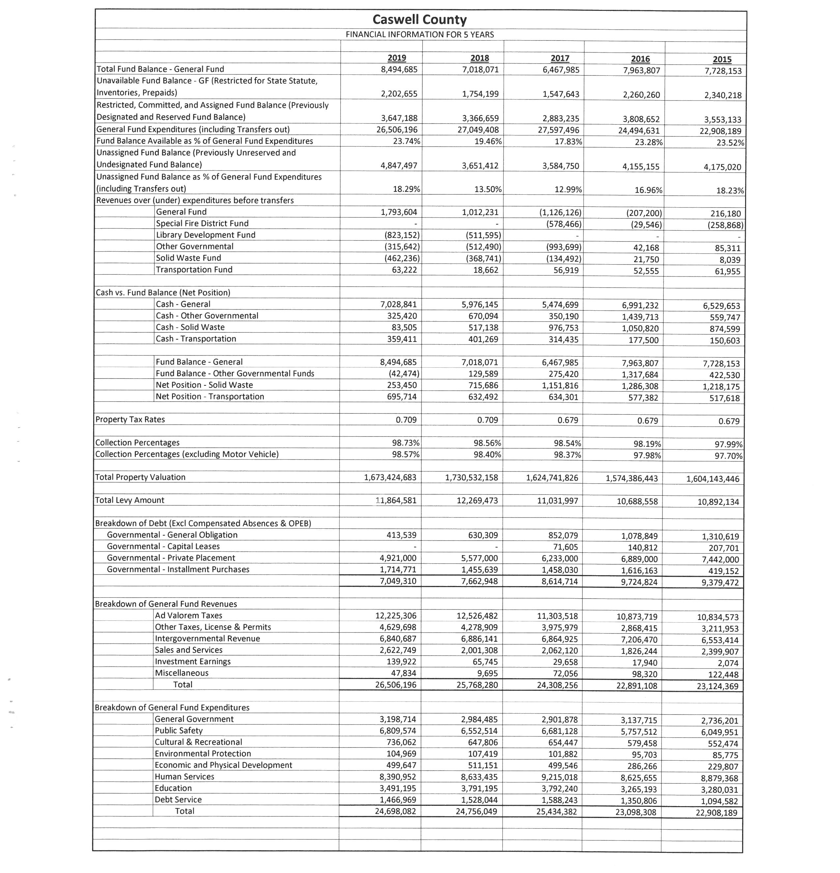

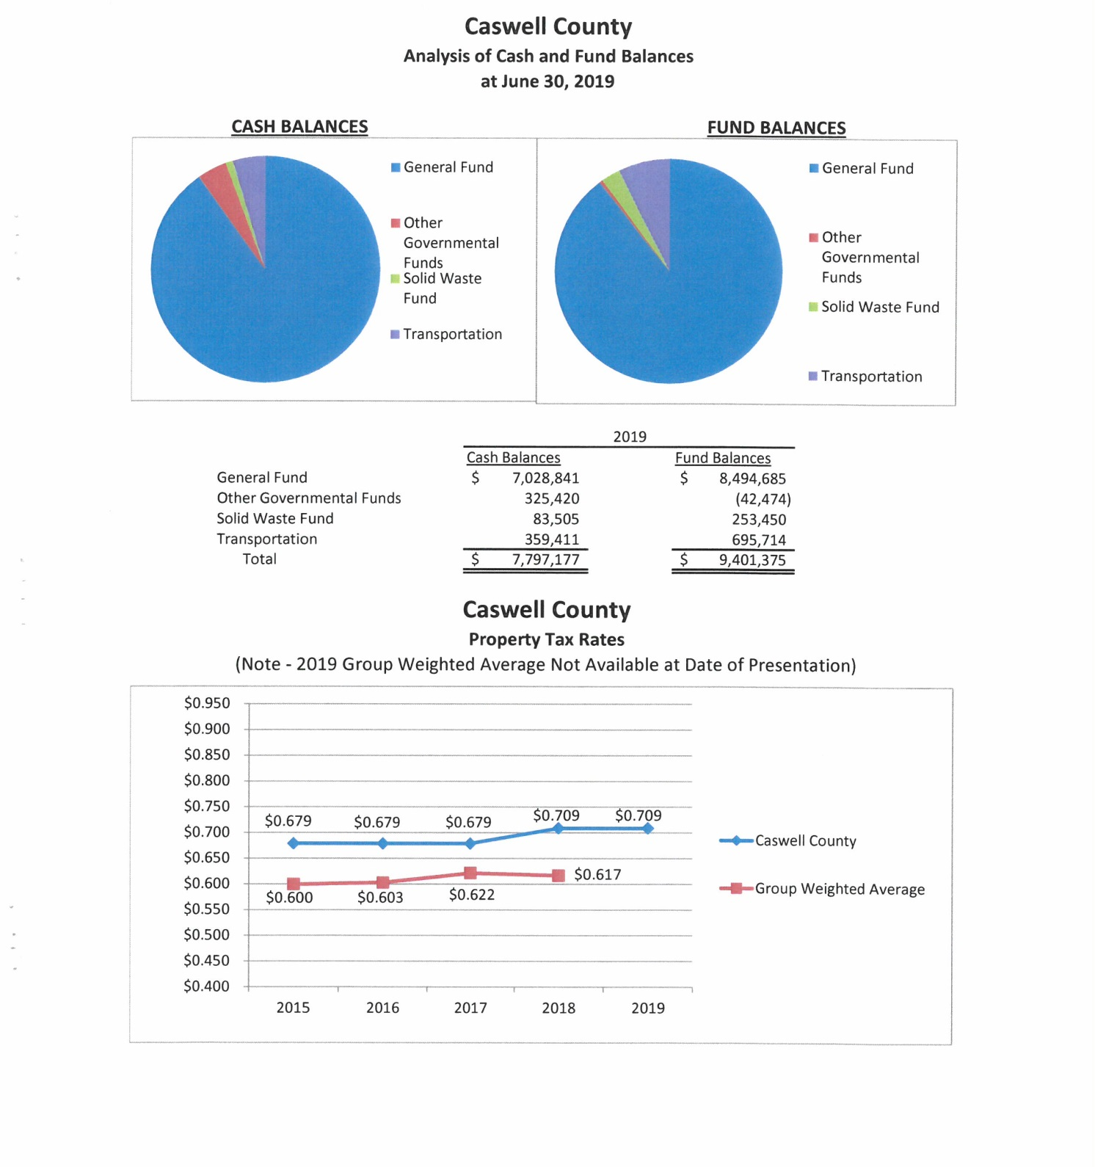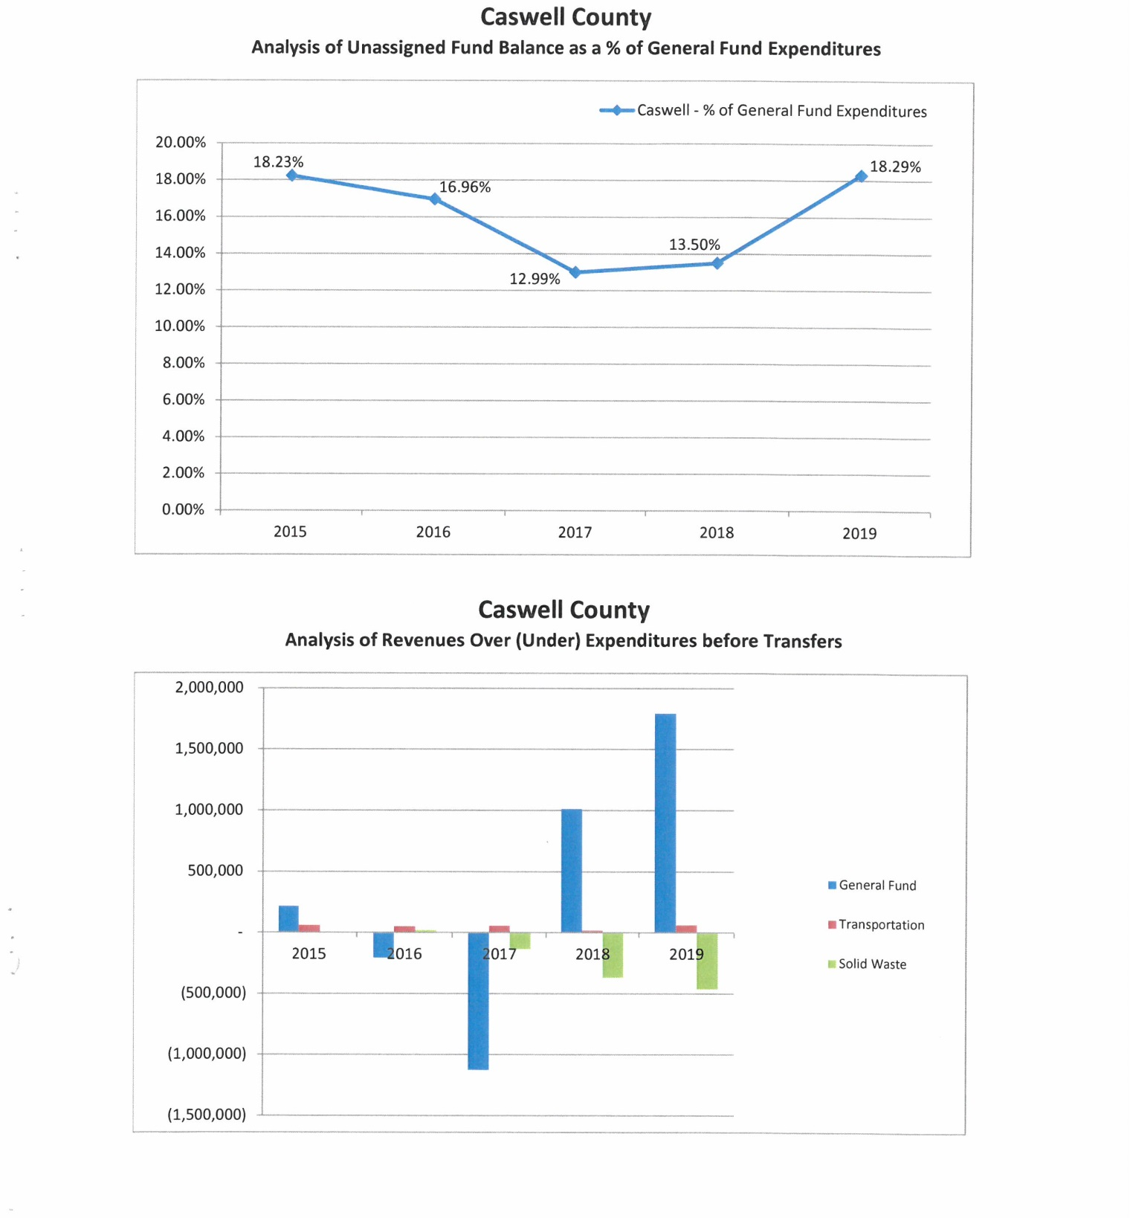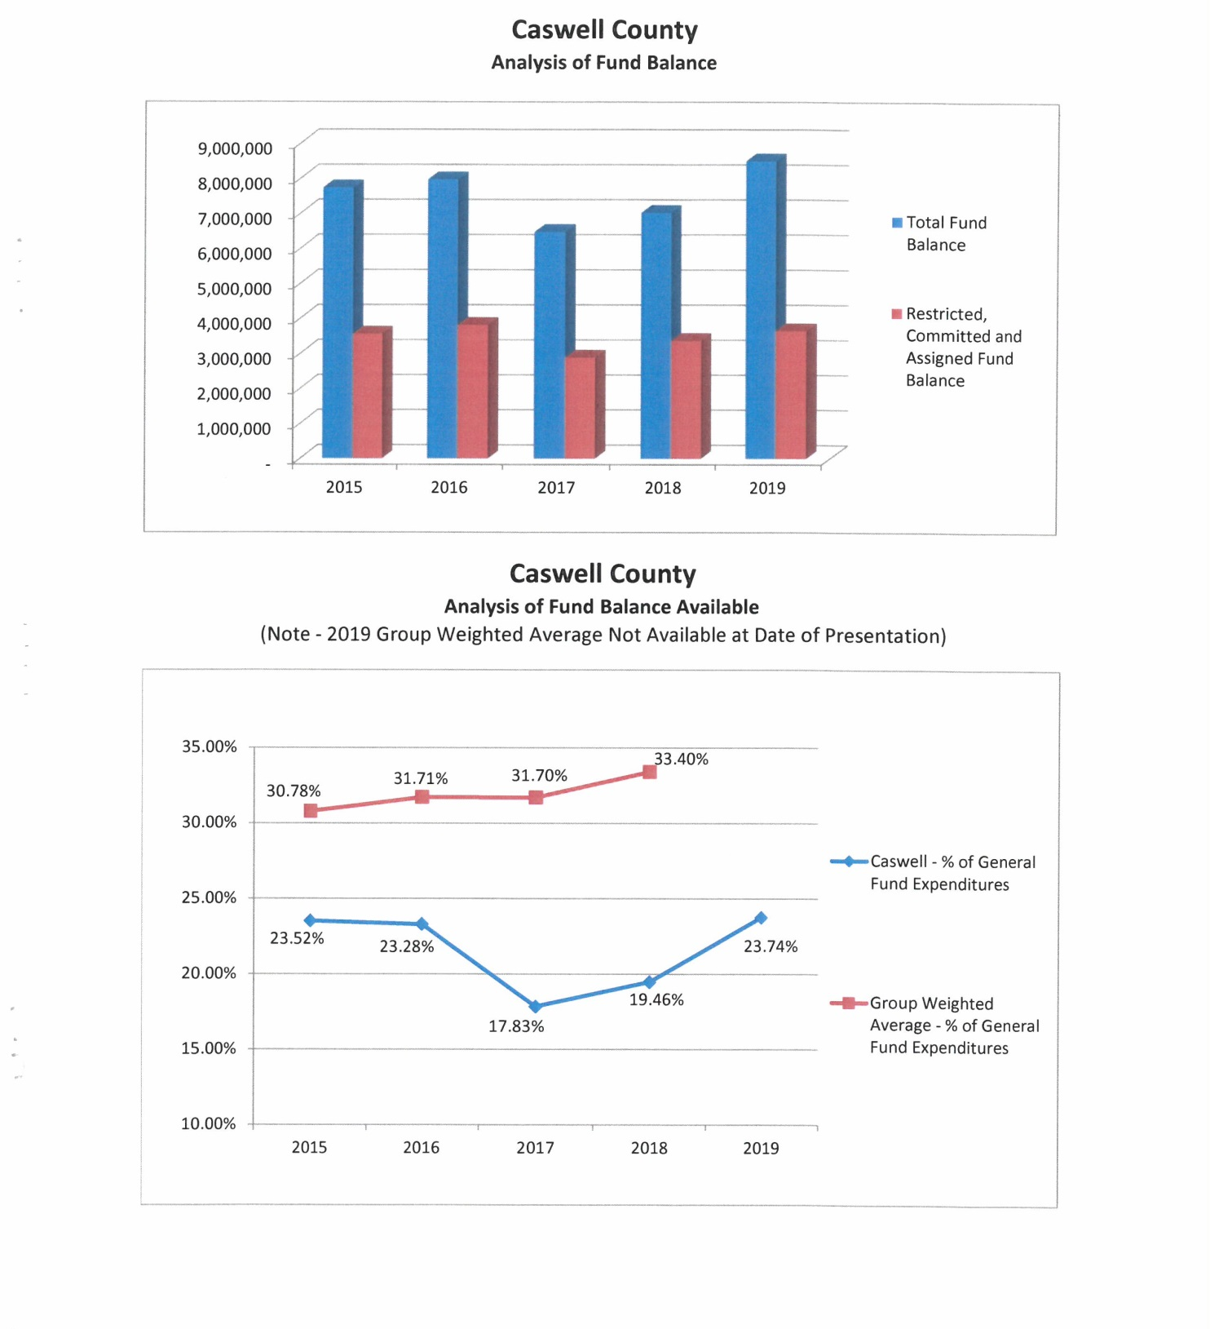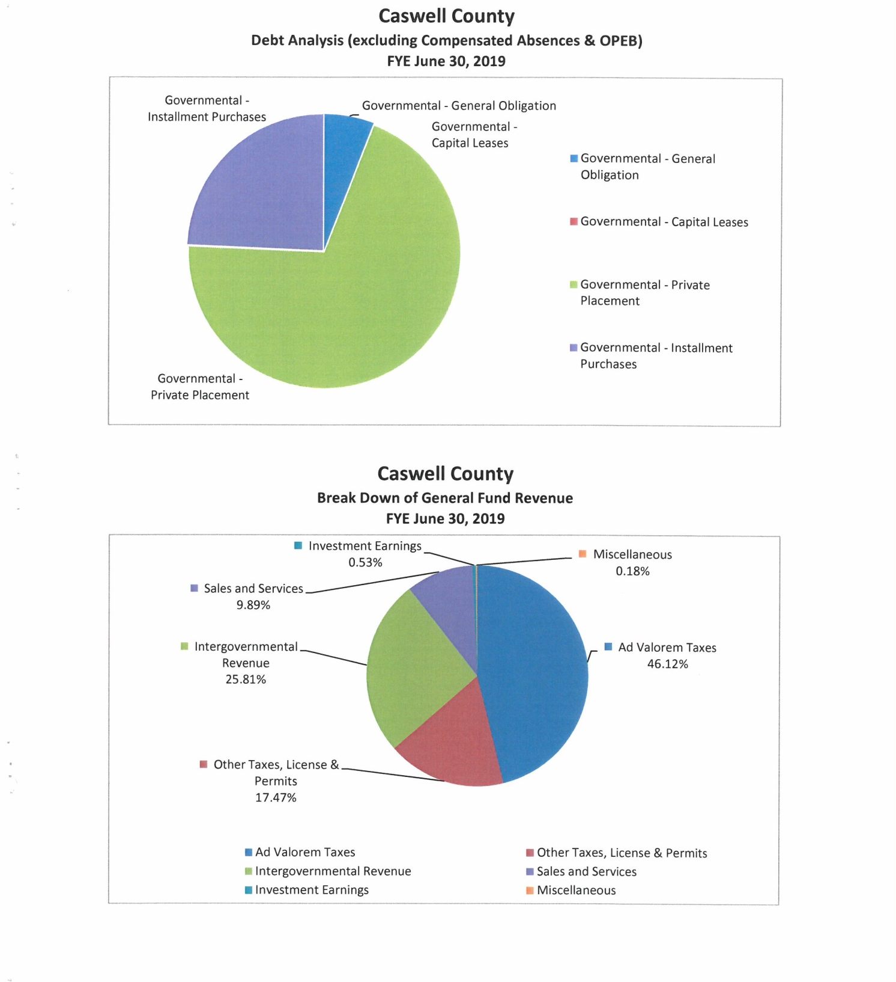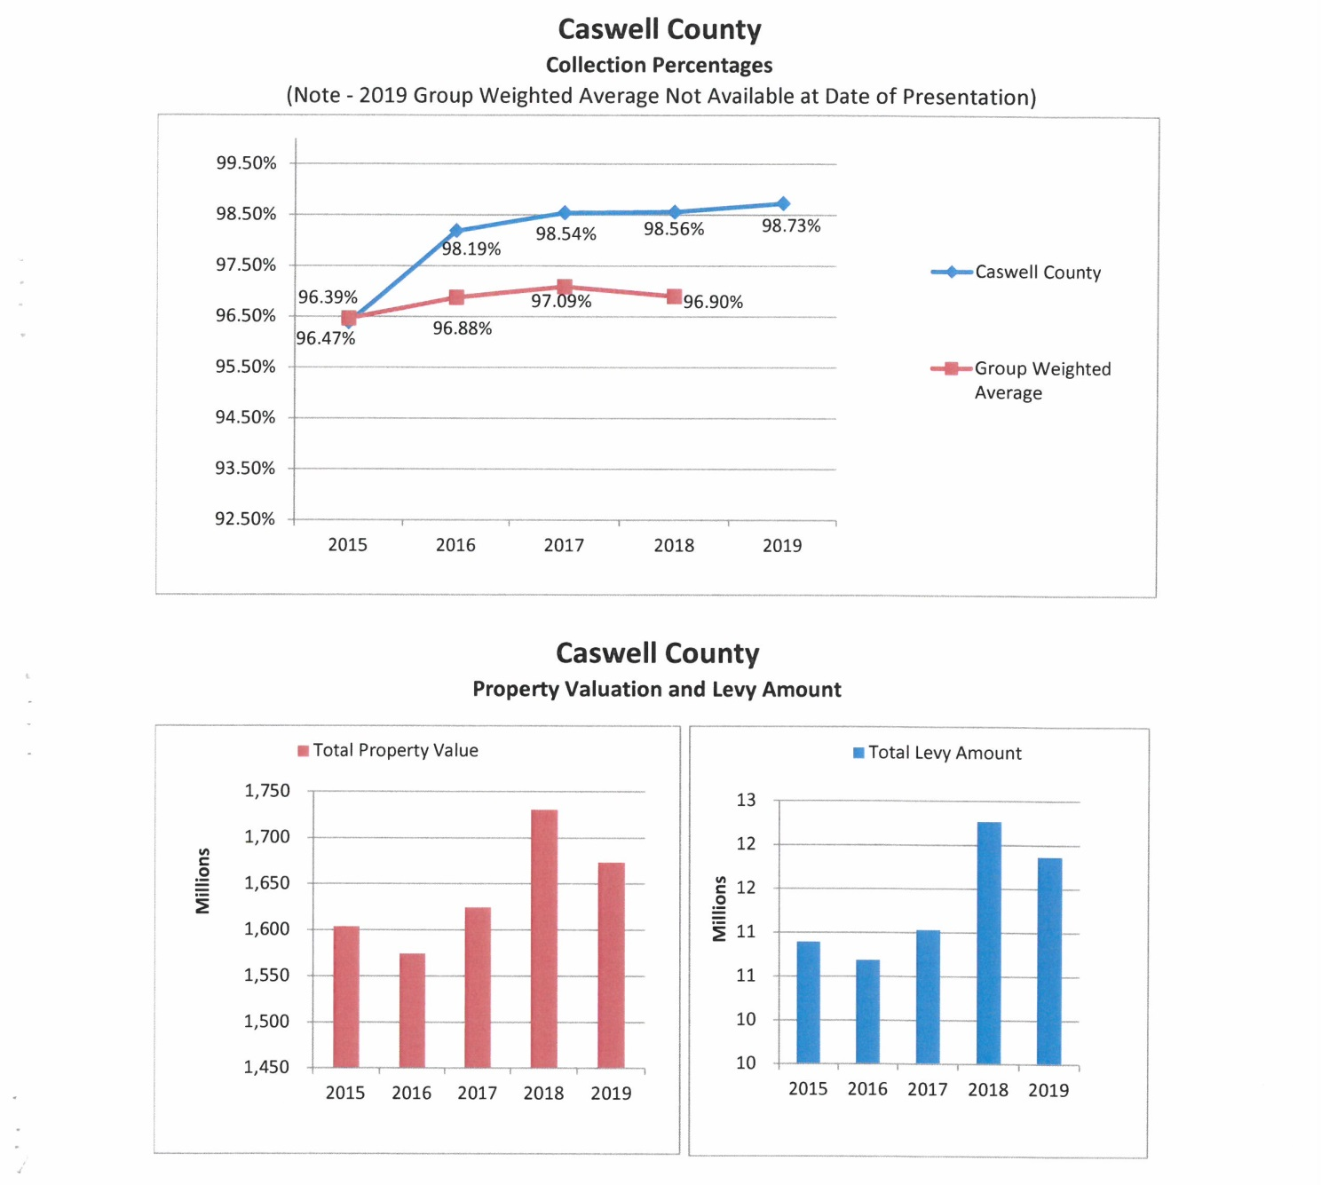

Commissioner Oestreicher stated that Mr. Thompson stated that the statewide collection percentage is 99%. Mr. Thompson responded that this is correct. Commissioner Oestreicher stated that it is odd that as a group it could be as low as 97% when statewide it is 99%. Mr. Thompson stated that he could not explain that. He added that he would get the Board a list of the counties that are included in the group weighted average. Commissioner Oestreicher stated that this would be wonderful.

Commissioner Hall asked why the property values and the levy amount for 2018 is higher than 2019. Mr. Thompson responded that he did not know the answer without looking into the data that was collected from the Tax Office and the property tax person could give the Board the answer as to why there is a decrease in those figures but he would get the Board an answer on that. Commissioner Hall stated that this is significant for Caswell. Mr. Thompson responded that he would get an answer to the question.

FOR THE RECORD

Commissioner Owen stated “Thank you Mr. Chairman, Board, recently there was information put out about a transaction between our county manager and a private citizen and citizens were asked to judge that material based on two deeds that were presented. I just want to give you some more information so that we understand what took place because I know that Mr. Chandler and our county manager were quite taken back by this. But anyway so I went to see our county manager not asking him to prove anything because I believe you are innocent until proven guilty. But while I was in there with him he shared with me some documents that I want to make aware to the public and to this Board concerning the transaction that took place and then you have more information to make your decision on. These legal documents regarding the purchase of this property showed the description of the property, the price of the property as well as the payment schedule for the property but what is more important is the date that is on those legal documents and the date was November 16, 2017, 8 months before this Board voted to secure the property on the corner. I think that’s significant. He also shared with me some private research on what the property was going for at that time it was purchased as well as photographs and other information so for me to believe there was quid pro quo I think you have to believe either they had a magic ball or that they were able to predict that this Board would vote for that or you have to believe that our county manager has a great control over this Board which neither one of those is true. So I just wanted to get that into public record so now you have more information to make up your mind as to whether or not that is what it was said to be. Thank you.”

JUDGE BLACKWELL’S PORTRAIT

Commissioner Owen stated that back several meeting ago the Board was asked to give permission to the Local Bar Association for them to place the portrait of Judge Blackwell in the courthouse. He added that the motion was made by Commissioner Bill Carter to place this portrait at the courthouse and since that time the Board received a letter from the Local Bar Association requesting that this motion be changed to allow the placement of Judge Blackwell’s portrait in the historic courthouse for which Judge Blackwell did most of his work as a lawyer and/or judge. Commissioner Owen stated that he talked with Commissioner Carter about this and he did not have a problem with this change on the motion.

Commissioner Owen moved, seconded by Chairman McVey to allow the Local Bar Association to place Judge Robert Blackwell’s portrait in the historic courthouse with the consultation with the county manager in regards as to where the portrait will be placed.

Commissioner S. Carter stated “I’m fine with them making that request; I agree that most of his work was done in this building. I do want us to keep in mind the historic integrity of this building, the setting a precedent for instance you do have to keep in mind that it was again we don’t have the date per say but several meetings back we decided that we would come up with a policy for that and someone from the Bar Association was supposed to be selected to meet with me and the county manager to determine that so we still need to set that meeting up and get a policy made for that before we, you know, have other requests brought to us but I do want to make provision that is this building get rented out specifically if this portrait is placed in this room that if there is an event the portrait can be removed from the wall for the sake of the people taking pictures, having wedding ceremonies, etc. other than that I have no problem with this personally.”

Upon a vote of the motion, the motion carried unanimously.

APPROVAL OF PROCLAMATION IN SUPPORT OF
NATIONAL RADON ACTION MONTH

Mr. Miller read the proclamation to the Board.

Commissioner S. Carter stated “I would like to have all the signatures on this please.”

Commissioner Oestreicher moved, seconded by Commissioner S. Carter to approve the proclamation.

Mr. Miller stated that in conversations with the County’s environmental health professionals there are elevated levels of radon in the northern and northwest parts of Caswell County so it is pertinent to the County and that it is important that the citizens are educated about testing for radon. He added that Environmental Health has a limited amount of free radon test kits available on a first come, first serve basis. Mr. Miller stated that radon test kits are available at many home improvement stores for around $15. He added that this is an issue that can be fixed and he urged everyone to take this serious.

Caswell County
Proclamation In Support of
National Radon Action Month In Caswell County, North Carolina

WHEREAS, radon is a colorless, odorless, radioactive gas that may threaten the health of our citizens and their families;

WHEREAS, radon is the second leading cause of lung cancer in the U.S. and is the leading cause of lung cancer in non-smokers;

WHEREAS, the National Academy of Sciences estimates that up to 21,000 lung cancer deaths occur in the United States each year;

WHEREAS, radon is found in one in 15 homes across the U.S. have elevated radon
levels;

WHEREAS, any home may have elevated levels of radon, even if neighboring homes do not, and living in a home with an average radon level of 4 picocuries per liter of air poses a similar risk of developing lung cancer as smoking half a pack of cigarettes a day; and

WHEREAS, testing for radon is simple and inexpensive and radon problems can be fixed;

WHEREAS, Caswell County, the U.S. Surgeon General, the U.S. Environmental Protection Agency, the NC Department of Health and Human Services’ NC Radon Program and the North Carolina Advisory Committee on Cancer Coordination and Control support efforts to encourage homeowners to test their homes for radon, have elevated levels of radon reduced;

WHEREAS, many residents in Caswell County don’t know about radon, yet need to know, for the safety and health of their families and a proclamation of National Radon Action Month is an opportunity to educate individuals on the available measures to reduce radon;

NOW, THEREFORE, the Caswell County Board of Commissioners do hereby proclaim:

JANUARY 2020 as National Radon Action Month

This the 6th day of January, 2020.

S/Rick McVey ________________ S/David Owen_________________
Rick McVey, Chairman David Owen, Vice Chairman
S/Sterling Carter________________ S/William E. Carter ____________
Sterling Carter, Commissioner William E. Carter, Commissioner
S/Nathaniel Hall________________ S/Jeremiah Jefferies____________
Nathaniel Hall, Commissioner Jeremiah Jefferies, Commissioner
S/Steve Oestreicher___________
Steve Oestreicher, Commissioner
Attest:
S/Paula P. Seamster_______________
Paula P. Seamster, Clerk to the Board

Upon a vote of the motion, the motion carried unanimously.

Commissioner Hall asked if the Board could request someone from Environmental Health to come to maybe the next meeting to do a presentation on what makes radon more prevalent in some homes than others and this would give everyone the idea of the urgency of doing these tests. Chairman McVey responded that it would be fine if it suits the Board. He directed the county manager to have someone at the next meeting to speak to the Board about radon.

APPOINTMENTS TO BOARDS AND COMMITTEES
Caswell County Cemeteries Board of Trustees

Commissioner Hall asked if the list is representative of the citizens of Caswell County in terms of race, ethnicity, etc. Commissioner S. Carter responded “This list is based on who was interested and applied just like any other board. Commissioner Hall asked if the answer to his question was yes or no. Commissioner S. Carter responded “Well the answer would be no in my opinion if you were to ask me that but that would reflect other boards as well. These people have an interest in genealogy and history; I can’t help who applied and who didn’t apply.”

Commissioner Owen stated that he is going to bring forward in the Board’s planning meeting a discussion about the County’s boards and committees and how to move forward with those looking at demographic statistics and other things and he would be interested in what Commissioner Hall has to say.

Commissioner Owen moved, seconded by Commissioner S. Carter to appoint Jared L. Terrell, Lisa Ashby, Ginny Mitchell, and Earl Wrenn to the Caswell County Cemeteries Board of Trustees. The motion carried by a vote of five to one with Commissioner Hall voting no.

Chairman McVey stated that per the Board’s discussion in December Commissioner Sterling Carter had offered to head up the Cemeteries Board of Trustees as a commissioner representative, ex-officio.

Commissioner Owen asked Commissioner Carter to have full disclosure to state his relationship with a person serving on this board. Commissioner S. Carter responded “My mother is on there. She is a genealogist in her own right.”

Commissioner Owen moved, seconded by Commissioner Oestreicher to appoint Commissioner S. Carter to the Caswell County Cemeteries Board of Trustees.

Commissioner Hall asked if the Board would appoint the chair and he wanted to know the in relation to the ex-officio commissioner. Commissioner S. Carter responded “This board, it has been done in other counties that this board appoints the chair. The group appoints its own vice chair, secretary or we could let the group appoint the chair for the meetings.” Mr. Ferrell responded that this is a new entity for the county and traditionally there would be a set of bylaws for each committee and the entity will bring those bylaws back before the Board for approval. He suggested that the Board directs the group as its first order of business to develop a set of bylaws.

Commissioner Owen stated that the group should also bring back procedures that this committee will use in regards to cemeteries, etc. Commissioner S. Carter responded “They will follow state statute.” Commissioner Owen asked that this be included in the bylaws so that the Board is aware. Commissioner S. Carter responded “We are. So which route do y’all want to go as far as the chairing part of it? That is up to this Board’s discretion.” Commissioner Owen stated that most of the local boards appoint their own and that is fine with him.

Commissioner Hall stated that if the Board’s member is ex-officio then the Board has lost a vote…Commissioner S. Carter responded “You can have a voting ex-officio member.” Mr. Ferrell responded that this is a bylaw issue and the bylaws can allow the ex-officio to vote. Commissioner S. Carter asked “Do you prefer that I vote?” Commissioner Hall responded yes. Mr. Ferrell stated that there is nothing that prevents a commissioner member from voting on the cemetery board of trustees.

Commissioner S. Carter asked “So are we developing the bylaws per this Board’s approval or do you just want a copy of the bylaws once they are adopted?” Commissioner Owen responded that with this committee the Board should approve the bylaws due to the implications of this county taking over abandoned cemeteries the Board needs to be aware of the process. Commissioner S. Carter stated “Sure. We will at our first meeting develop bylaws hopefully and bring them back maybe at the next meeting, if not the first meeting in February.”

Commissioner Oestreicher stated that it is his understanding that this board of trustees has no authority on their own. Commissioner S. Carter responded “Their authority is in lieu of us doing these things.” Commissioner Oestreicher repeated that this board of trustees would have no authority on their own and that they would make a recommendation to the Board for action. Commissioner S. Carter responded “Yes.” Commissioner Oestreicher stated that this needed to be included in the bylaws as well. Commissioner S. Carter responded “Fine.”

Upon a vote of the motion, the motion carried unanimously.

COUNTY MANAGER’S UPDATES
Sheriff’s Grant – Body Cameras

Mr. Miller stated that the Sheriff’s Office will submit a grant for body cameras for the officers to use. He added that the county will not have to supply the matching funds due to the Sheriff will be able to use DA funds to satisfy this matching requirement.

Family Services’ Grant Applications

Mr. Miller stated that Family Services of Caswell County will be submitting several grant applications. He added that this information was included in the Board’s agenda packet. Mr. Miller stated that these grants will require matching funds but these matching funds will be allocated in the next budget due to these grants will not be awarded during the next fiscal year. He stated that in one of the grants will involve some staff changes and duties will be realigned and there will be an increase in salary for the Court Advocate Outreach Assistant to Court Advocate Outreach Specialist from $13.70 to $14.05 an hour.

Town of Yanceyville

Mr. Miller stated that the Town of Yanceyville is rezoning a couple properties and one of those properties belongs to Caswell County located at 251 East Church Street, the Juvenile Probation/Parole Office. He stated that this will be rezoned from RR-8 (restricted residential) to OS-1. Mr. Miller informed the Board that the Town of Yanceyville will hold a public hearing tomorrow night on this rezoning and he would be in attendance for this public hearing.

Commissioner Hall asked if the county had had any preliminary discussions with the Town about this change. Mr. Miller responded no because the new zone meets the current use of the property. He added that he had not had any conversations with the Town about this. Mr. Miller asked if there was any objection on the Board’s behalf on the rezoning of this property. Commissioner Hall stated that he did not have any objection but many locations are going to mixed use zoning where office space and residential can be in the same location. Mr. Miller responded that this is correct. He added that he thinks the Town is trying to align the properties up to its current use.

MORATORIUM

Commissioner Owen stated that before the Board moves on and the citizens have waited patiently on the moratorium and he asked if there was any questions or any discussions from the Board about the moratorium and whether or not the Board wants to vote today or wait until the next meeting. He added that he has some questions. Commissioner Owen stated that with Item 5 of the moratorium where it says metal recycling and salvage facilities. He stated that there is a difference between a processing facility and a collection facility. Commissioner Owen stated that there is a collection facility in his district and it is just a holding place until it can be moved to the processing plant. He did not know if the Board wanted to do away with all of this or make a distinction between a processing plant and a collection plant. Mr. Ferrell responded that how the list of uses came about in section 5 is the public hearing notice was given an expansive view and there is another expansive view with power generating facilities. He asked for direction from the Commissioners on what uses they intend to be subject to the moratorium for the time period of the ordinance. Mr. Ferrell stated that it is appropriate for the Board to narrow the list down to what they intend to be subject to the moratorium. Commissioner Owen stated that he just brought it up to the Board and the moratorium can be left as is but there is a difference between processing and collecting. He stated that he is all for a moratorium but at the same time he does not want the Board to be so restrictive to eliminate businesses that are non-polluting to come into the county. Commissioner Owen asked for the Board’s feelings on this use.

Commissioner S. Carter stated “I was in favor of striking that and a few others. At our last meeting our directive was polluting industries and not this all inclusive definition of heavy industrial development. Now I would a like to ask also if we could retitle back to polluting industries versus heavy industrial development.” Someone in the audience asked Commissioner S. Carter to repeat what he said. Commissioner S. Carter continued “At our last meeting we directed the county attorney to draft a moratorium for polluting industries. Now we have a draft in front of us that says heavy industrial development and that includes additional industries that we did not discuss prior and so I am in favor of striking out the unnecessaries that are not polluting industries personally.” Mr. Ferrell responded that from his perspective it is a draft that the Board can change as it see fit. He added that he chose heavy industrial development just as a catch all and it can be changed to polluting industries. Commissioner S. Carter stated “So that’s my recommendation to the Board that we go back and use the words polluting industries.”

Commissioner Hall stated that he would feel more comfortable if this moratorium was put on the next agenda for voting and this would give the Board the opportunity to look at the terms and words as well as the citizens the opportunity to review the moratorium. Commissioner S. Carter responded “I will just say, I don’t agree with that course of action. We’ve had ample time to prepare for this. When was this emailed to us?” Commissioner Oestreicher stated “Tuesday.” Commissioner S. Carter responded “Last Tuesday, that’s ample time to read and determine what we want in it.”

Commissioner Oestreicher stated that he agreed with Commissioner Carter that the moratorium is consistent with the Board’s previous discussions. He added that the Board has had the information since last Tuesday. Commissioner Oestreicher stated that he questions the inclusion of alternative energy generating facilities because this sounds like a solar farm so he was not quite sure what to do about this one and it may need some further consideration. He suggested as a compromise that the Board could vote on the moratorium tomorrow at the work session which is a public meeting.” Commissioner S. Carter responded “I think we can make the necessary changes today, I really do. If the majority of this Board is in favor of changing that title then the references to heavy industrial development to polluting industries. I move to changing the title from heavy industrial development to polluting industrial and then we can strike the ones that we don’t agree with and move on.”

Commissioner S. Carter moved to changing the title from heavy industrial development to polluting industries.

Commissioner Oestreicher noted that per previous discussions that the impact of this moratorium began with the publication of the public notice, the effect of this moratorium and asked for confirmation from the county attorney. Mr. Ferrell responded that there is logic that once there is a notice to the public that a moratorium is being considered on specific uses that companies look to the publication date of the moratorium so he thought this was correct. Commissioner Oestreicher stated that he hopes this is clear to everyone. Mr. Ferrell responded that the moratorium will not start until the adoption of the ordinance and will be the effective date. Commissioner Oestreicher stated that he was asking about the effective date. Mr. Ferrell responded that the effective date is when the ordinance is adopted.

Ms. Leslie Zimmerman came to the podium and stated that the Board can drag their feet forever and added that the audience needed to understand what is going on because they have been told something completely different. She asked when exactly will the moratorium take place and she asked for a definitive answer. Mr. Ferrell responded that he has been very clear that the moratorium is not effective until it is adopted by the Board of Commissioners in the form of an ordinance. Ms. Zimmerman stated that the Board can drag their feet every two weeks and say that they need to educate the people, add more things, take things away, and in the meantime zoning is never going to be put in place. She asked why everyone was at the meeting.

Commissioner Oestreicher stated “Let me clarify again please. It’s my understanding that if a new industry submitted an application or permit yesterday that that permit or any construction or operation of that facility would be prohibited pending the official approval of this moratorium. Is that correct or not?” Mr. Ferrell responded “Well what I can do is read you the statutory language if that is helpful to you.” Commissioner Oestreicher stated “I’d like just a simple answer.”

Commissioner S. Carter stated “We were told, we were told that.” Mr. Ferrell responded “Let me read you the language of the ordinance on what your authority is limited to right and I can’t vary from what the statutory authority is okay.” Mr. Ferrell read NCGS 153A-340.

Commissioner Oestreicher asked “So all the preexisting or the grandfathering is fairly clear, that anything applied to prior to the publication of the public hearing notice is in effect? Anything after the publication of the public hearing date is restricted?” Mr. Ferrell responded “Not anything, what the statute says is a preliminary or final subdivision plat so any of the final or preliminary subdivision plats that are submitted after the publication should you adopt the moratorium would be subject to the moratorium. That is how I read the ordinance; I mean excuse me that is how I read the statute…” Commissioner Oestreicher asked if this could be broken down into simple, understandable language because he did not think everyone understands what this means. Mr. Miller responded that most of the paperwork that the county requires would be subject to the vested rights and vested right would not be granted based on the notice of the public hearing. He added that the county does require environmental assessments and if there are issues with the environmental assessment then the county requires and environmental impact statement from the company and he is not aware of any environmental assessment forms or environmental impact forms being received at this point for any project within the county. Commissioner Oestreicher asked if a nuclear waste storage facility decided to lease land in the county yesterday are they prohibited. Mr. Miller responded that he understood the questions but he could not answer hypotheticals, there is data that is needed. Commissioner Oestreicher stated “If that’s the case then I firmly believe that we need to take action on this today.” Commissioner S. Carter responded “Yes.”

Commissioner Owen stated that the Board needed to address the changes that it is looking at and then proceed.

Commissioner S. Carter moved, seconded by Commissioner Oestreicher to strike all references to heavy industrial development and change it to polluting industries.

Mr. Miller stated that he has had a couple of meeting with the Cooperative Extension Director about some agricultural projects or activities do require water permits but none currently in the county would be applicable to this. Mr. Travis Hoesli, Cooperative Extension Director, stated that the only thing he found that would be affected by water environmental impacts would be animal confinement operations because they are required by state and federal law to do water assessments. He added that there are some of these in the county and it would restrict them until the moratorium is lifted.

Commissioner S. Carter asked “Mr. Chairman, where is that in here?” Mr. Ferrell responded that it is located in Section 2.1. but this can be changed.

Commissioner S. Carter stated “A motion and a second are on the floor.” Chairman McVey responded that the Board is not finished with discussions.

Commissioner Oestreicher asked if it is possible to exempt a certain industry. Mr. Ferrell responded yes this can be done. Commissioner Oestreicher asked if it could be in general and state ‘as exempted by the Board of Commissioners’. Mr. Ferrell responded that he did not believe it could be done this way but the animal confine facilities could be exempted.

Commissioner Jefferies stated that he thought that the vote on this should wait until the next meeting so that the farmers will have an opportunity to speak on this because it could impact them.

Mr. Ferrell stated that the language about polluting industries came from the initial draft that was provided to him by the commissioners.

Commissioner Oestreicher stated that the Board could discuss the ordinance in it entirety or go through it step by step.

Chairman McVey asked if changes could be made to this if the Board votes on it now. Mr. Ferrell responded yes changes could be made.

Commissioner S. Carter stated “I will restate my motion.

Commissioner S. Carter moved, seconded by Commissioner Oestreicher to change the title of the ordinance from heavy industrial development to polluting industries as advertised and to strike all references to heavy industrial development.

Commissioner Owen stated that what is in the document is what determines what it is and not the title. Mr. Ferrell responded that this just changes what Commissioner Carter wants term wise but it is just changing a defined term in the document.

Upon a vote of the motion, the motion carried by a vote of four to two with Commissioners Hall and Jefferies voting no.

Commissioner S. Carter moved, seconded by Commissioner Oestreicher to strike in Section 2. Subsection 5. Alternative energy generating facilities and metal recycling and salvage facilities from the definition.

Commissioner S. Carter stated “Which essentially goes back to the list that we provided in the original draft during the last meeting.”

Commissioner Owen stated that the only problem he has is a metal recycling processing center can pollute so he is not happy with doing away with this part. He suggested adding processing facility and this would allow collections. Commissioner S. Carter responded “So rewrite it as a processing facility.” Commissioner Owen stated it should read metal recycling processing facilities. Commissioner S. Carter responded “So instead of striking that we are adding processing facilities?” Commissioner Owen stated if it is okay with the Board.

Commissioner S. Carter asked “Do you need a clarification on that?” The clerk responded no.

Commissioner Oestreicher asked how this would be handled. Mr. Ferrell responded that there is a friendly amendment to the motion so the motion now is to delete in Section 2. Item 5. alternative energy generating facilities from the list and to revise the final entry to metal recycling processing facilities and delete salvage.

Commissioner S. Carter moved, seconded by Commissioner Oestreicher to strike in Section 2. Subsection 5. Alternative energy generating facilities and metal recycling processing facilities from the definition. The motion carried by a vote of four to two with Commissioners Hall and Jefferies voting no.

Mr. Ferrell asked the Board if they intended the definition of polluting industries to only include the list of industries in Section 2.5 which is not how it is currently written because these are just examples or those uses that require air and water quality permits which is how it is currently written. Commissioner Oestreicher responded that he did not think the Board was at this point yet. Mr. Ferrell stated that this is very important and a key distinction before leaving the definitions.

Commissioner Oestreicher stated that now the Board could address the exemption and leave the definition of polluting industries broad with the list of examples and make a provision for agricultural industries or operations as discussed by the county manager. Commissioner S. Carter responded “In the first draft it just says subject to.” Commissioner Oestreicher stated in Section 2.1 add in ‘those operations restricted by…regulations related to agriculture.’ He asked where the best location for this exemption. Mr. Ferrell recommended having it in the fourth line ‘within the County whose operation is restricted by state or federal permits relating to air or water quality regulations except for regulations pertaining to agricultural uses or large animal confinement facilities.

Commissioner Oestreicher moved, seconded by Commissioner S. Carter to exempt only the animal confinement facilities. The motion carried by a vote of four to two with Commissioners Hall and Jefferies voting no.

Commissioner Oestreicher asked if any of these changes will affect the rest of the ordinance. Mr. Ferrell responded that it is a very broad ordinance so there could be conflicts with other facilities but the definition is air and water quality permit requirements except for the animal confinement facilities. Commissioner Oestreicher stated that this was not his question; his question was if there are any conflicts in the document due to the changes. Mr. Ferrell responded that he did not believe there are any conflicts. He added that there is one technical correction that needs to be made; the numeration is off in the document.

Commissioner Oestreicher moved, seconded by Commissioner S. Carter to make sure that the numeration is corrected. The motion carried unanimously.

Commissioner S. Carter asked “Question, what is currently Section 8 what is the Caswell County Heavy Industrial Development Ordinance, is that this technically?” Mr. Ferrell asked where in the document this is located. Commissioner S. Carter continued “Section 8 Establishment of Moratorium at the bottom of the page.” Mr. Ferrell responded that this is the ordinance and the change will be Caswell County Polluting Industries Ordinance. Commissioner S. Carter stated “Okay. So in the same section on the next page, the schedule of meetings, what changes can you explain that were made between our draft and this draft?” Mr. Ferrell responded that originally he thought about going with a specific schedule based on the county planner’s outline on zoning ordinance adoption but his concern was if it got off schedule the ordinance would be in conflict with the actual process so what is in this is the action items that the county will take during the moratorium. He asked if this answered Commissioner Carter’s question. Commissioner S. Carter asked “Can we keep the language from the first draft stating numerous educational meetings and public hearings, was this not specific?” Mr. Ferrell responded that the Board can take whatever outreach efforts it intends to take during the next year and add reference to that in the ordinance.

Commissioner Oestreicher stated that multiple public hearings will be scheduled and held. Commissioner S. Carter responded “In our draft we also listed educational community meetings in addition to public hearings.” Commissioner Oestreicher asked if educational meeting could be added to the ordinance. Commissioner S. Carter responded “That is what I am suggesting.”

Mr. Ferrell stated that he understands that the potential change is ‘to anticipate multiple hearings, community meetings and educational workshops’. Commissioner S. Carter responded “Well in this we had regular commissioner meetings and in addition to that we would have work sessions, commissioner work sessions to work on zoning. It is like you said I don’t want to be in conflict with ourselves versus just saying we would have those sessions.” Mr. Ferrell asked if it could say community meetings and work sessions. Commissioner S. Carter responded “That is fine.” Mr. Ferrell stated that the revised language would be ‘it’s anticipated that multiple public hearings, community meetings and work sessions will be scheduled and held by the Caswell County Planning Board and/or the Caswell County Board of Commissioners.” Commissioner S. Carter asked “Is it necessary that we have the Planning Board wrote in this?” Mr. Ferrell responded yes because when talking about countywide zoning statutes require the planning board to have a role in that process.

Commissioner S. Carter moved, seconded by Commissioner Oestreicher to amend the sentence in Section 8 in the second paragraph to read ‘It is anticipated that multiple public hearings, community meetings, and work sessions will be held.

Commissioner Jefferies asked the county attorney if he sells a piece of land to a neighbor and he builds a house and if he drives his tractor by that piece of property what is going to happen to him because his tractor is noisy. Mr. Ferrell responded that this ordinance is not keyed on decibel levels or noise, it was in the original draft but it is not in this draft. Commissioner Jefferies stated that he wanted to make sure.

Chairman McVey asked Commissioner Carter to restate his motion.

Commissioner S. Carter moved, seconded by Commissioner Oestreicher to amend Section 8 in the second paragraph should read ‘It is anticipated that multiple public hearings, community meetings, and work sessions will be scheduled and held. The motion carried unanimously.

Commissioner S. Carter stated “Mr. Chairman just a general question, back to the original draft this is a question for the attorney is there any way this Section 2 in the first draft can be incorporated into this draft so that there is more explanatory purpose to provide why and what these things impact.” Mr. Ferrell responded sure. He added that in Section 3 Factual Findings there is an attempt to do that and explain the conditions and problems that necessitate that but other information could be added to this. Commissioner S. Carter asked “Can this first draft precede the beginning of Section 2 of the second draft as kind of like a mission statement sort of?” Mr. Ferrell stated that he needed to look at it. Commissioner S. Carter continued “If y’all need to see that I have it.”

Commissioner Oestreicher asked Commissioner Carter to read what he is recommending. Commissioner S. Carter responded “I can. The current one in front of us has some details of the ordinance but this was more of a statement from the county. ‘The purpose of this moratorium is as follows: to protect the health of the citizens of Caswell County against potential adverse health effects from harmful emissions, noise, and contamination of both water and air; to protect the public safety of the citizens against potential failure of containing and controlling of fires and explosions and increased traffic and damage to roadways; to protect the environment of Caswell County against air and water pollution, thereby protecting streams, tributaries and groundwater supplies; to protect and retain local wildlife species including local marine life and to protect a local non-profit community zoo from various environmental and aesthetic effects of such industries; to protect and preserve local farm lands from potential contamination; to preserve the aesthetics of the rural, peaceful and residential lifestyle of the citizens of Caswell County including promoting the peace and safety of local places of worship, cemeteries, historic properties, independent businesses, and institutions of public education; to promote the rural population growth of Caswell County and its associated tax base, appropriate economic development and to protect the general welfare and property values of the citizens of Caswell County.’ So that was more of a mission statement of why we are requiring the ordinance and I think that should be included in this.” Mr. Ferrell responded that this could be included as a new Item 1 in Section 2. Commissioner Oestreicher asked if this would weaken the ordinance. Mr. Ferrell responded that it is a purpose section and if it is consistent with the Board’s purpose it is fine but the provision that give him pause is the provision regarding tax base and he recommended removing this portion. Commissioner Oestreicher stated that the tax reference does seem a bit self-serving. Mr. Ferrell responded that this could be added as Section 2 Item 1. Commissioner S. Carter asked “It begins with this.” Commissioner Oestreicher asked Commissioner S. Carter about his thoughts on the tax reference.” Commissioner S. Carter responded “I did not know whether or not to put that but I think, you know, the beginning of that is to promote the rural population growth of Caswell County and its associated tax base.” Mr. Ferrell stated that any references to the tax base can be deleted and property values. Commissioner S. Carter responded “I would like to leave the property values in.” Commissioner Oestreicher stated that his only concern is there is no study to prove this. Mr. Ferrell responded that he did not think this would matter. He added that the key element is what the county does next and the moratorium was step one of what has to be done.

Commissioner S. Carter moved, seconded by Commissioner Oestreicher to amend the current draft ordinance by adding Section 2 of the first draft into Section 2.1 of the new draft and to remove the associate tax base from that language. The motion carried unanimously.

Commissioner S. Carter asked “Do we know…is it reasonable to take a recess to type these changes for final approval?” Mr. Ferrell responded that he did not think the changes needed to be typed because the Board has made the appropriate motions and the clerk has taken notes and he has taken notes so it is not necessary but it can be done.

Commissioner Oestreicher asked if the $500 is the right amount for a fine. Mr. Ferrell responded that it could say ‘the maximum allowed by law’ because the county has to follow state statute when it comes to fines. Commissioner Oestreicher asked if there is a statute of limitation on the fine. Mr. Ferrell responded that he would have to check on this. Commissioner Oestreicher asked if this could be changed to ‘$1000 or the statutory limit whichever is greater’. Mr. Ferrell responded that if the statutory limit is less that would be the limit. Commissioner S. Carter stated “Let’s just do statutory limits.” Mr. Ferrell responded that he would set a number because in certain situations civil penalties don’t have a prescriptive number, criminal penalties do. Commissioner Oestreicher asked if this could read ‘$2,000 or maximum statutory limit’. Mr. Ferrell responded that he thought this could be done.

Commissioner Oestreicher moved, seconded by Commissioner S. Carter to change the new Section 7, old Section 10, change $500 to $2,000 or the maximum statutory limit per offense. The motion carried unanimously.

Commissioner S. Carter moved, seconded by Commissioner Owen to adopt the moratorium as amended. The motion carried by a vote of five to one with Commissioner Jefferies voting no.

ANNOUNCEMENTS AND UPCOMING EVENTS

A. Board of Commissioners Work Session – Tuesday, January 7, 2020 at 9:00 a.m.
911 Center.
B. Caswell County Blood Drive – Wednesday, January 29, 2020 at 10:00 a.m. to
2:00 p.m. – Senior Center
C. Caswell County Board of Commissioners, Town of Yanceyville and Town of Milton
Joint Meeting – Thursday, February 13, 2020 at 6:00 p.m. – 911 Center.

The clerk asked the Board if lunch would need to be order for the Commissioners Work Session. Chairman McVey responded that if necessary the Board will take a break to get lunch.

Commissioner S. Carter asked “Would it not be best if we have the signature line page for this moratorium before we all disappear today since we have one missing and there is one no vote, just to make sure that we have that accurate as far as the final version goes?” Commissioner Oestreicher responded that it could be signed tomorrow. Commissioner Owen stated that it is already in affect with the adoption.

Commissioner Hall stated “Mr. Chairman before we adjourn I just want to make a comment. I want to go on the record indicating that I supported or support the moratorium and have been since we started the hearings however in an effort to do so quickly something that will probably have no impact on the current issue or the company at hand we may have created more problems than we needed to by voting so quickly and not working this out. Our general counsel has alerted us that it will be tight, these are my words, to get everything accomplished that we want to get accomplished in a year and what I think is we may have overlooked some things again in our haste to do it quickly.”

Commissioner S. Carter stated “Mr. Chairman to that affect, should we not go ahead and schedule some form of a meeting, work session, now?” Chairman McVey responded “I think we could form that work session tomorrow.” Commissioner S. Carter continued “Can we do that during the work session?” Commissioner Owen responded “If it is on the work session agenda we can.” Commissioner S. Carter stated “Okay.”

ADJOURNMENT

At 11:11 a.m. Commissioner Oestreicher moved, seconded by Commissioner S. Carter to adjourn. The motion carried unanimously.

________________________________ ___________________________
Paula P. Seamster Rick McVey
Clerk to the Board Chairman

******************************************************************************

